**Crime Data Analysis**

**Objective & Subjective questions**

**Objective Question:**

1. **Crime Type Analysis:** Assess the frequency of each crime type to identify the most prevalent crimes occurring in the area.

* Assessing the frequency of each crime type is a crucial aspect of crime analysis, enabling law enforcement agencies, and community organizations to understand the nature and prevalence of criminal activities in each area.
* So, we count the number of crimes in each type of crime to know the frequency of crime in crime type.
* According to our given data we analyse that total Number of crimes is **91K.**

Explain the formula for calculating-

**Total Case = COUNT (crimes_data_2022[Type])**

And the maximum number of crimes happens in Theft that is **20.3K** and minimum number of crimes happened in Human Trafficking is **10**, Gambling is **4**, non-Criminal is **2**, Other Narcotic Violation and Public Indecency is **1**.

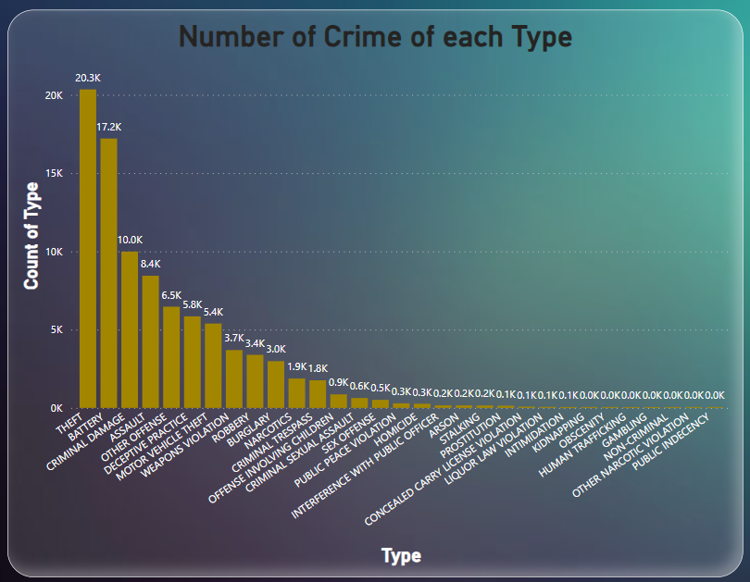

1. **Arrest Rate Evaluation:** Analyse the percentage of reported incidents that have resulted in an arrest to gauge law enforcement effectiveness.

* Analysing the arrest rate is a crucial aspect of evaluating law enforcement effectiveness and assessing the outcomes of reported incidents.
* As per given data the total number of cases was **91K** and the total number of Arrest is **11K.** Arrest Rate is **12.30.**
* Explain the formula for calculating the arrest rate:

**(Number of Arrests / Number of Reported Incidents) * 100.**

* As per our analysis we find that the maximum number of arrests was in **Battery Type** of crime and **Weapon Violation** crime that was **2394** and **2339** and the minimum number of arrests in Narcotic Violation and Public Indecency that was **1** and **1** arrest in both.

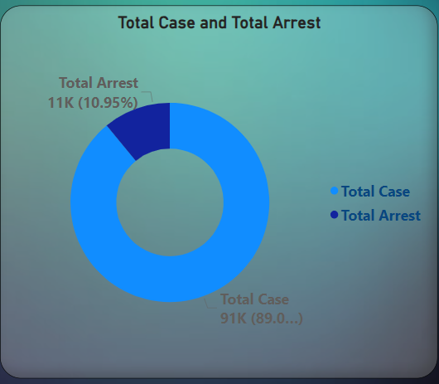**

1. **District Crime Distribution Assessment:** Calculate the number of crimes in each district to understand how crime is distributed across the city and identify high-crime areas.

* Assessing the District Crime Distribution Assessment is a crucial aspect of evaluating law enforcement effectiveness and assessing the outcomes of reported incidents and prevalence of criminal activities in each District.
* As per our analysis we find the number of Cases in the district. In District 6 we get **5763** and district 8 we get **5701** total cases was registered. These top two districts crime was very high.
* In District 5 registered crime was very low that is 5, and the second low crime was registered in District 20 that is **1838.**

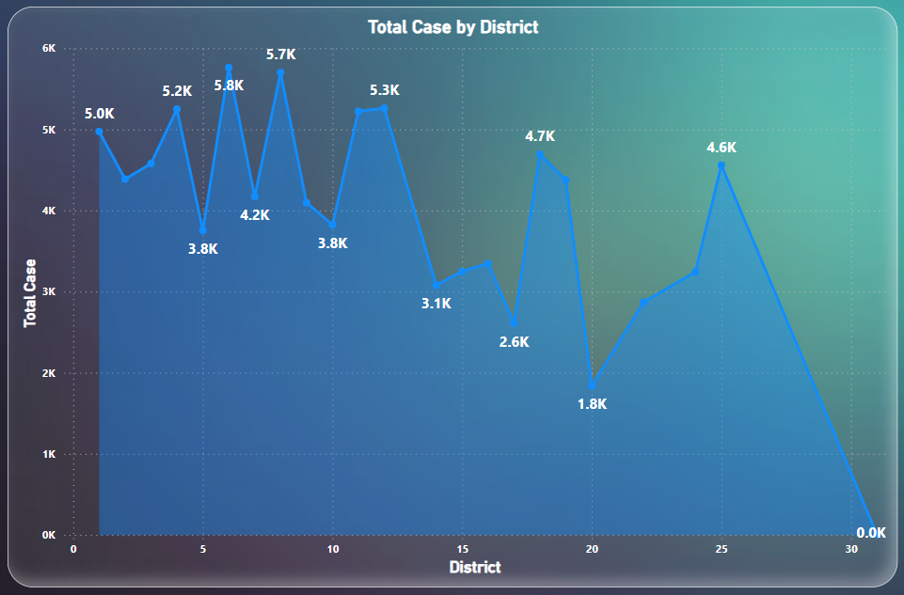

1. **Domestic Crime Proportion Analysis:** Analyse the ratio of domestic-related crimes to other types of crimes to understand the prevalence of domestic incidents.

Introduce the concept of domestic crime proportion analysis and its significance in understanding the prevalence and dynamics of domestic incidents.

Define what constitutes domestic-related crimes, which typically involve acts of violence, abuse, or harassment perpetrated within familial or intimate partner relationships.

As per our analysis total domestic crime reported was 18K.

Explain the formula for calculating the Domestic Crime:

**=CALCULATE(COUNTROWS('crimes_data_2022'),'crimes_data_2022'**

**[Domestic]=TRUE)**

And the domestic Ratio is **0.20** calculated with formula:

**= DIVIDE ('crimes_data_2022'[Domestic crime],'crimes_data_2022'[Total Case])**

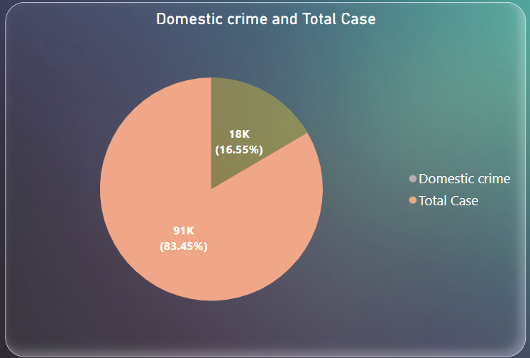

1. Is there any “**Location Description**” where the number of crimes is higher than expected? Come up with a table or visualization in which one can judge the frequency of crimes at each Location Description type.

* Determine the expected frequency of crimes at each location description type. This can be based on historical data, population density, crime rates in similar areas, or other relevant factors.
* Consider using statistical methods such as calculating the number of crimes per location description across a specified time.
* The maximum number of crimes happened in **Street** that was **23151** crimes and on second position **Apartments** **19177** crimes registered as per location.
* And the minimum number of crimes registered at **Airports, Barbar Shop, CTA “L” Train, Garage, Liquor Store, Stairwell and Vestibule** that is only **1**.

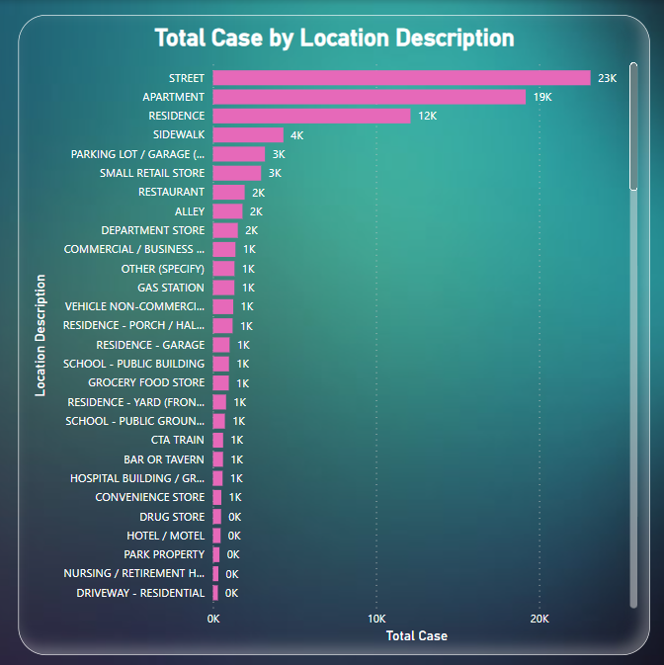

1. What is the average time between reporting and solving a case as per the data?

Calculate the time difference between the reporting timestamp and the solving timestamp for each case.

This can be done by subtracting the registered date from the updated date, resulting in a duration.

Formula used for this column is:

**Solve Case in Day = DATEDIFF ('crimes_data_2022'[Date], crimes_data_2022**

**[Updated Date], DAY)**

Aggregate the time differences calculated in step 2 to find the average time spent on solving cases.

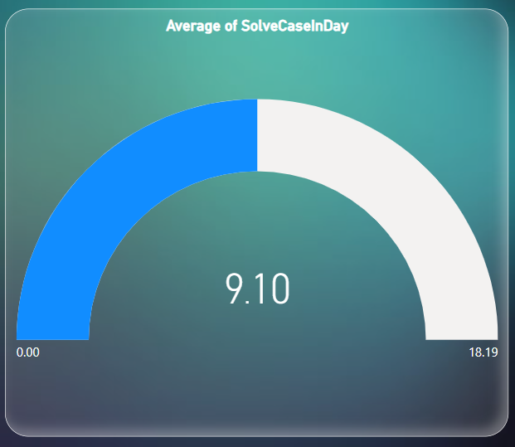

1. In order to reward the patrol officers, find the patrol area where the crimes reported were under control.

To identify patrol areas where crimes reported were under control and potentially reward patrol officers for their effectiveness.

Collect and aggregate crime data by location description, summarizing the number and types of crimes reported in each area over a specific period.

So, as per analysis we get that **Airports, Barbar Shop, CTA “L” Train, Garage, Liquor Store, Railroad Property, Stairwell and Vestibule** that is only **1**.

Once areas with effective patrols are identified, recognize and reward patrol officers who have contributed to maintaining low crime rates or reducing crime levels in those areas.

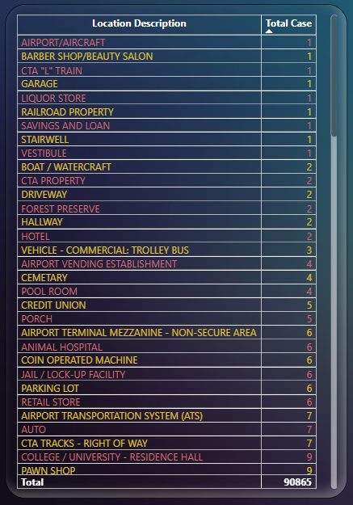

**Subjective Questions**

1. Is there any **year-wise** change in crime rates? If not, what could be the mistake in that operation?

To analyse year-wise changes in crime rates, you typically need data spanning multiple years to observe trends and variations over time. However, if you only have data for a single year, such as 2022 in this case, it would not be possible to assess year-wise changes because there are no other years for comparison.

The mistake in the operation was assuming that the dataset contained information for multiple years when it only pertains to the year 2022. Without data from other years, it's not feasible to analyse year-wise changes in crime rates.

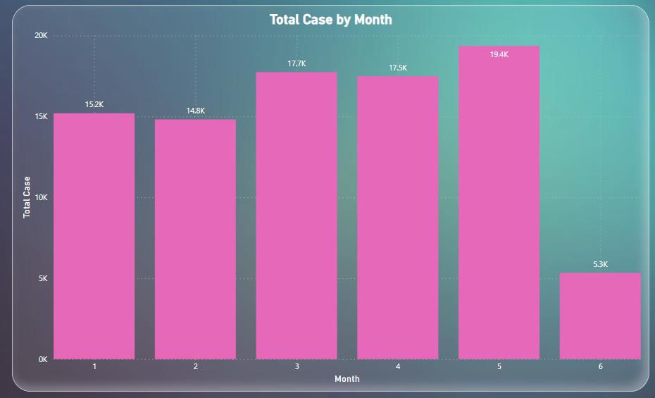

1. How can we reduce the no. of crimes, and which types of crime should we focus on to achieve improvement in the overall number of crimes?

Targeted Policing Strategies: Increased police patrols and law enforcement presence in high-crime areas.

Continuous Monitoring and Evaluation: Installation of surveillance cameras and security lighting to determine criminal activity and enhance visibility.

Preventive Measures: Collaboration with local businesses, schools, religious institutions, and community organizations to promote safety and crime prevention efforts.

Focus on High-Impact Crime Types: Analyse crime data to identify high-impact crime types that have a significant impact on public safety and community well-being. Focus on **THEFT, BATTERY, AND CRIMINAL DAMAGE** because the frequency of these crime is above than **10K**.



1. Which localities experience higher crime rates, and what measures can we ensure to reduce these numbers?

To identify localities experiencing higher crime rates and suggest measures to reduce these numbers, follow these steps:

* Use your dataset to analyse the frequency and types of crimes reported in different localities.
* Calculate crime rates for each locality by dividing the total number of reported crimes by the population or area size of the locality.

As per analysis we get the (41.976290414, -87.905227221) on this location 131 number of crimes was reported. And the minimum number of crimes reported on (41.64459158, -87.596781458) that was 1.

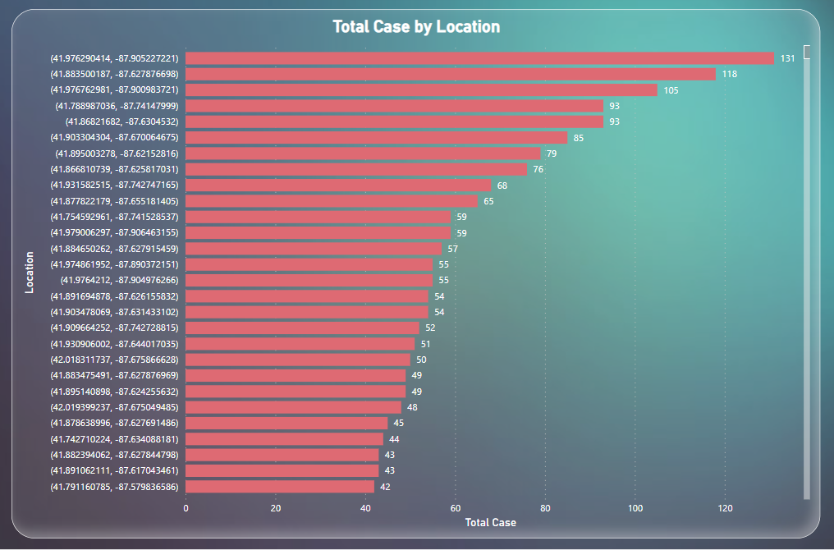

1. Can you suggest wards where security improvements should be made to reduce crime?

To suggest wards where security improvements should be made to reduce crime, it's essential to analyse crime data and identify areas with higher crime rates or specific types of crime.

Obtain and analyse crime data for different wards or neighbourhoods. Look at various types of crime, such as theft, robbery, property crimes, sex offenses, etc. Identify wards with higher crime rates or areas experiencing a surge in criminal activity.

In wards number **42** and **27** here the number of crimes was very high that is **4731** and **4250**, Also in wards number **6** and **24** crime number was **3294** and **3101**.

Implementation of surveillance cameras and security lighting can be effective strategies to deter criminal activity and enhance visibility in areas prone to crime. Here's how each measure can contribute to crime prevention. By combining these strategies and implementing a multi-faceted approach to crime prevention, communities can create safer environments, reduce opportunities for criminal behaviour.

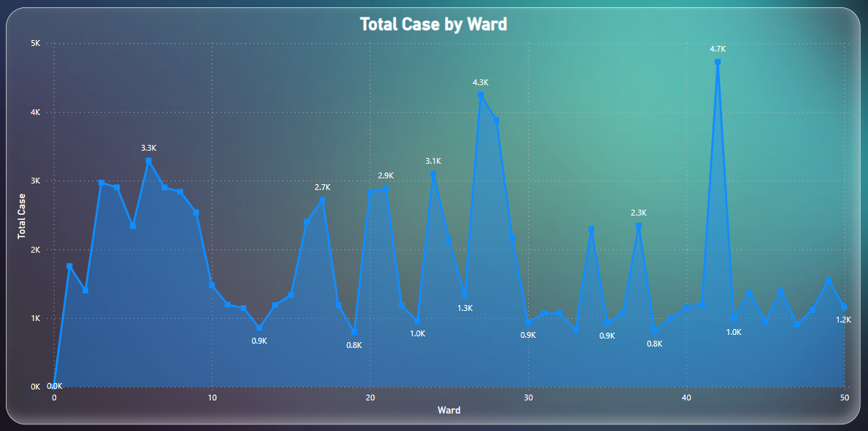

1. **Crime Rate Trend Analysis:** Monitor changes in crime rates over time to detect any discernible patterns or trends.

Crime rate trend analysis involves monitoring changes in crime rates over time to identify patterns, trends, and fluctuations in criminal activity.

* Crime rate trend analysis involves examining crime data over different time periods, such as daily, weekly, monthly, quarterly, or annually. Temporal analysis helps identify short-term fluctuations, seasonal variations, and long-term trends in crime rates.
* As per given data we have only few months of 2022 year of data like January to June. And the maximum number of crimes in May and minimum number of crimes happened in June. We don’t find any trend in these months.
* The findings of crime rate trend analysis are interpreted and presented in comprehensive reports, dashboards, and visualizations to communicate key insights to relevant stakeholders. A graph on a computer screen

  Description automatically generated

1. As per the previous reports, most of domestic crimes do not result in arrest due to public hesitation and family pressure, is this trend also visible in our data?

Based on the provided information, it appears that there is a significant disparity between the number of reported domestic crimes and the number of arrests made in connection with these incidents. Specifically, there were approximately 11,000 reported as total arrest, but only 2,278 arrests were made in domestic offenses.

This disparity suggests that a large portion of domestic crimes are not resulting in arrests. One possible explanation for this phenomenon could be the presence of public hesitation and family pressure, as mentioned in previous reports. Victims of domestic violence may face various barriers to reporting. Such as fear of reprisal from their abusers, concerns about the impact on their family dynamics, and social or cultural stigma surrounding domestic violence.

1. Could you generate a visual representation that emphasizes the frequently occurring terms within the **"Description"** column?

As per the analysis we get the Domestic Battery Simple is very high that is 8.0K and the very a smaller number of crimes in Unlawful use of computer.

* Drag the "Description" field to the axis of your visualization.
* Drag the "Number of Domestic Crimes" field to the values section.
* Sort the bars in descending order to highlight regions with the highest number of domestic crimes.

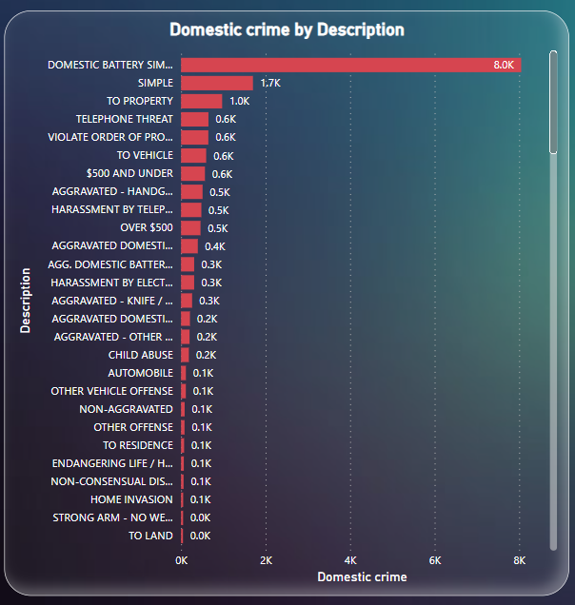

1. Are there any regions as per the data where the number of domestic crimes reported is very high?

To identify regions where the number of domestic crimes reported is very high, you can perform a data analysis using the available crime data.

Aggregate by Region:

Group the data by geographical regions, such as neighbourhoods, districts, or cities, depending on the level of granularity available in the dataset.

Calculate the total number of domestic crimes reported in each region.

Identify High-Risk Regions:

Analyse the aggregated data to identify regions where the number of domestic crimes reported is significantly higher compared to other regions.

Look for patterns or clusters of high-risk regions on maps or visualizations.

**In district 6 Domestic crime reported was very high that was 1637.**

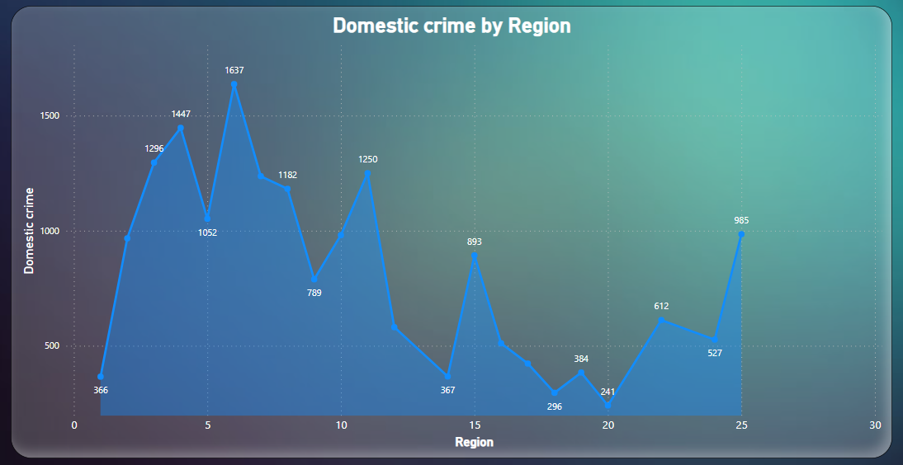

1. Is the solving time of cases also dependent upon the type and locality of crime?

Yes, the solving time of cases can be dependent on both the type and locality of the crime. Here's how:

Type of Crime:

* Certain types of crimes may require more extensive investigations, forensic analysis, or collaboration with specialized units, leading to longer solving times.

Locality of Crime:

* The locality where the crime occurs can influence the solving time due to various factors such as population density, urban or rural environment, socio-economic conditions, and law enforcement resources.

Overall, the solving time of cases can be influenced by a combination of factors related to the type of crime, the locality where it occurs, resource allocation by law enforcement agencies, and community dynamics.

